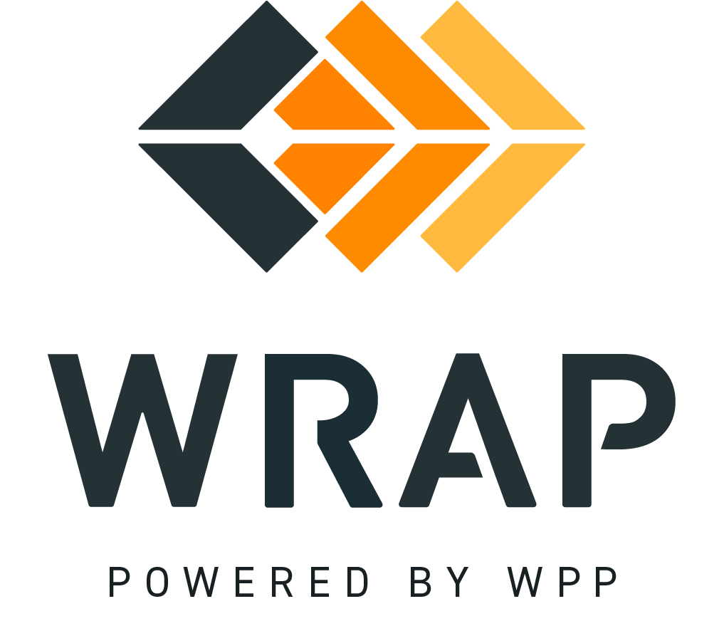

BPM 301 - Program Review Committee Workplan Development and Approval
Comments accepted between 2023-09-21 and 2023-10-17

01: Please supply any comments related to the Introduction, Definitions, or Background sections.

02: Please supply any comments related to the Change Request section (3).

03: Please supply any comments related to the Change Request - Change Request Form section (3.1).

04: Please supply any comments related to the Change Request - Compile Concepts section (3.2).

05: Please supply any comments related to the Change Request - PRC Review of Concepts section (3.3).

06: Please supply any comments related to the Change Request - Level of Effort Review section (3.4).

07: Please supply any comments to the Workplan Development section (4).

08: Please supply any comments to the Workplan Development - PRC Development of Workplan section (4.1).

09: Please supply any comments to the Workplan Development - Draft Workplan Review Process section (4.2).

10: Please supply any comments to the Workplan Development - Workplan Approval section (4.3).

General Comment

