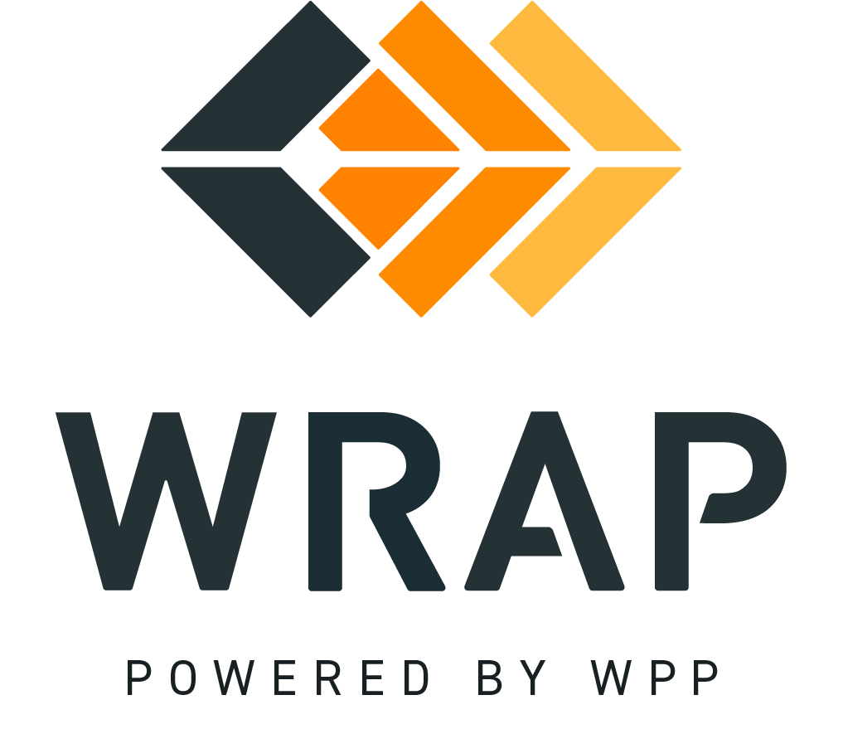

BPM 302 - Program Review Committee Proposal Development and Consideration
Comments accepted between 2023-10-23 and 2023-11-05

01: Please supply any comments related to the Introduction, Definitions, or Background sections.

02: Please supply any comments related to Proposal Development section (3).

03: Please supply any comments related to the Proposal Development - Task Force Creation section (3.1).

04: Please supply any comments related to the Proposal Development - Proposal Drafting Process section (3.2).

05: Please supply any comments related to the Proposal Review section (4).

06: Please supply any comments related to the Proposal Review - Public Comment section (4.1).

07: Please supply any comments related to the Proposal Review - COSR Comments section (4.2).

08: Please supply any comments related to the Proposal Review - PRC Recommendation Process section (4.3).

09: Please supply any comments related to the Proposal Review - RAPC Review section (4.4).

10: Please supply any comments related to the Proposal Review - COSR Formal Opposition to Endorsed Changed Proposal section (4.5).

11: Please supply any comments related to the Proposal Review - Board Interaction section (4.6).

General Comment

