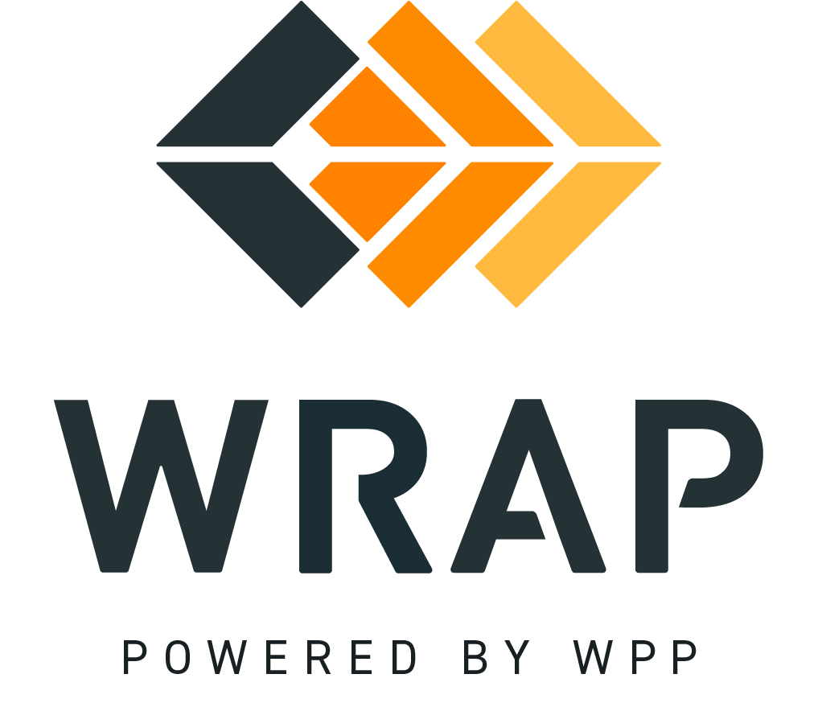

BPM 304 - Amendments to Schedule 1 and WRAP Agreement
Comments accepted between 2024-01-19 and 2024-02-02

01: Please supply any comments related to the Introduction or Definitions sections.

02: Please supply any comments related to the Amendment Requests section (2).

03: Please supply any comments related to the RAPC Amendment Review section (3).

04: Please supply any comments related to the RAPC Endorsement section (4).

05: Please supply any comments related to the Board of Directors Review section (5),

General Comment

