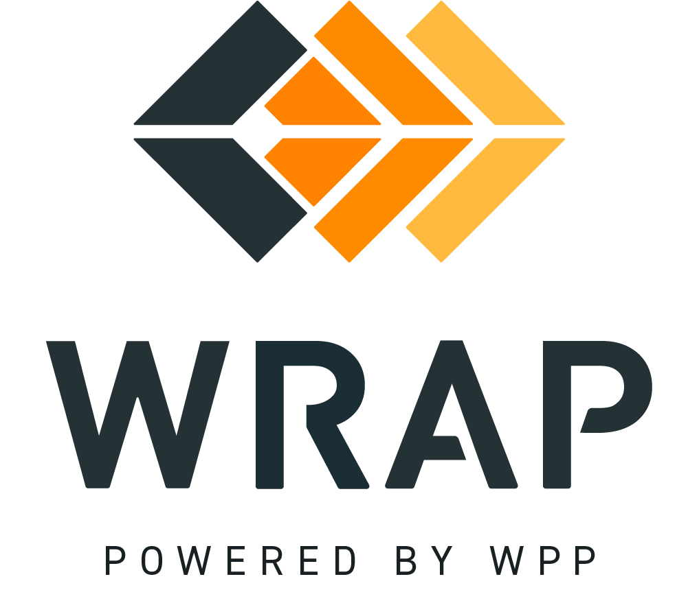

2024-NTFP-2
Comments accepted between 2025-01-15 and 2025-01-29

Please supply any comment related to the changes in BPM 107 Forward Showing Deficiency Charge

Please supply any comment related to the changes in BPM 109 Forward Showing Transition Period

Please supply any comment related to the changes in BPM 206 Settlement Pricing

Please supply any comment related to the changes in BPM 210 Operations Program Transition Period

Please supply any comment related to the changes in BPM 301 Workplan Development and Approval

Please supply any comment related to the changes in BPM 401 New Participant Onboarding

General Comment

