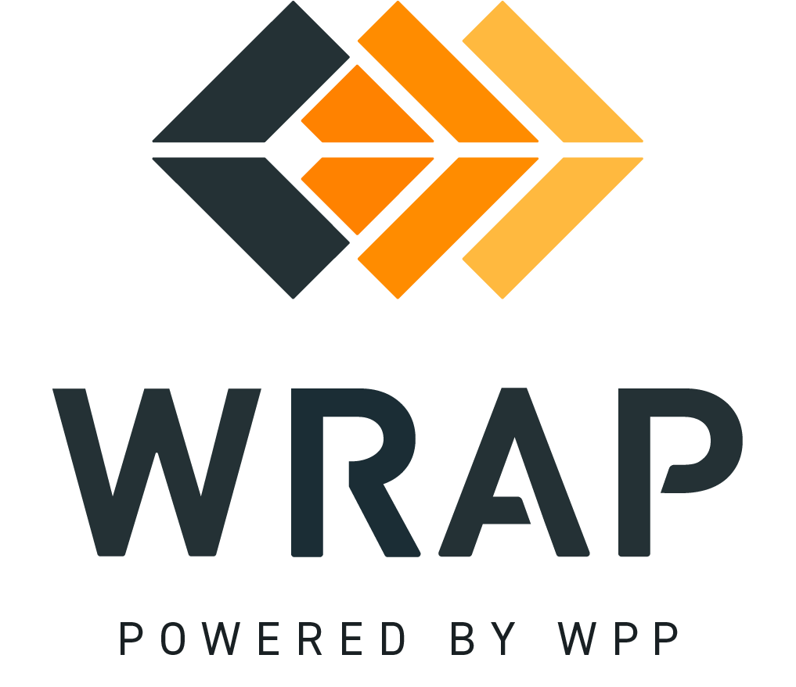

# CAISO Firm Transmission Proposal - PRC Workplan Task Force 8

Comments accepted between 2025-09-17 and 2025-10-17

01. Do you have any comments on the proposal itself?

02. Do you have any comments on the WRAP Qualifying Transmission definition, including whether the proposed language in part (iii) provides sufficient clarity for non-NERC priority transmission products such as CAISO’s Priority Wheeling Through?

03. Do you have any questions regarding the redlines to the WRAP Tariff?

04. Do you have any questions regarding the redlines to BPM 103 – Participant Forward Showing Capacity Requirements?

05. Do you have any questions regarding the redlines to BPM 106 – Qualifying Contracts?

06. Do you have any questions regarding the redlines to BPM 108 – Forward Showing Submittal Process?

07. Do you have any questions regarding the redlines to BPM 202 – Participant Sharing Calculation Inputs?

08. Do you have any questions regarding the redlines to BPM 204 – Holdback Requirement?

09. Do you have any questions regarding the redlines to BPM 209 – Energy Delivery Failure Charge?

General Comment