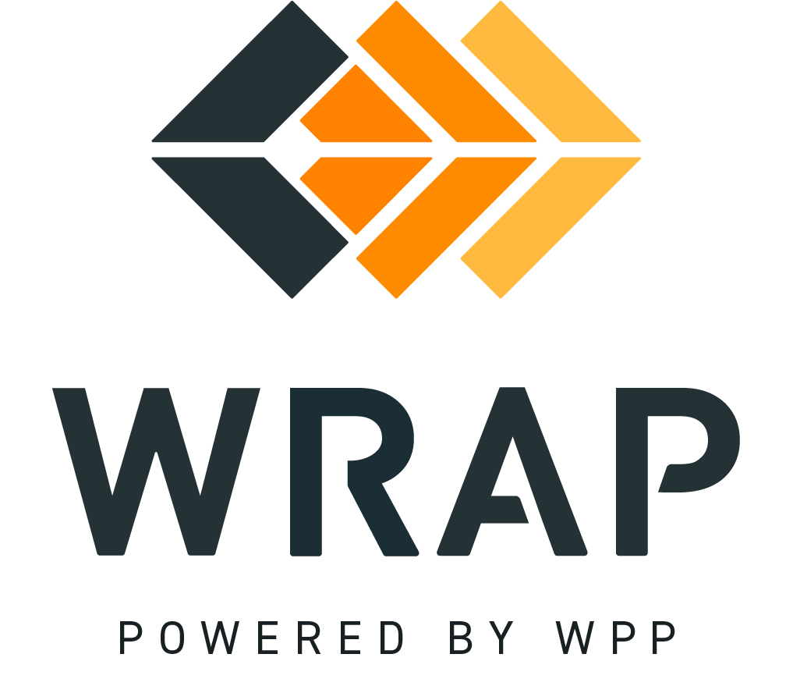

2025-EP-01 (BPM 102 Edits)
Comments accepted between 2025-11-17 and 2025-12-04

General Comment

