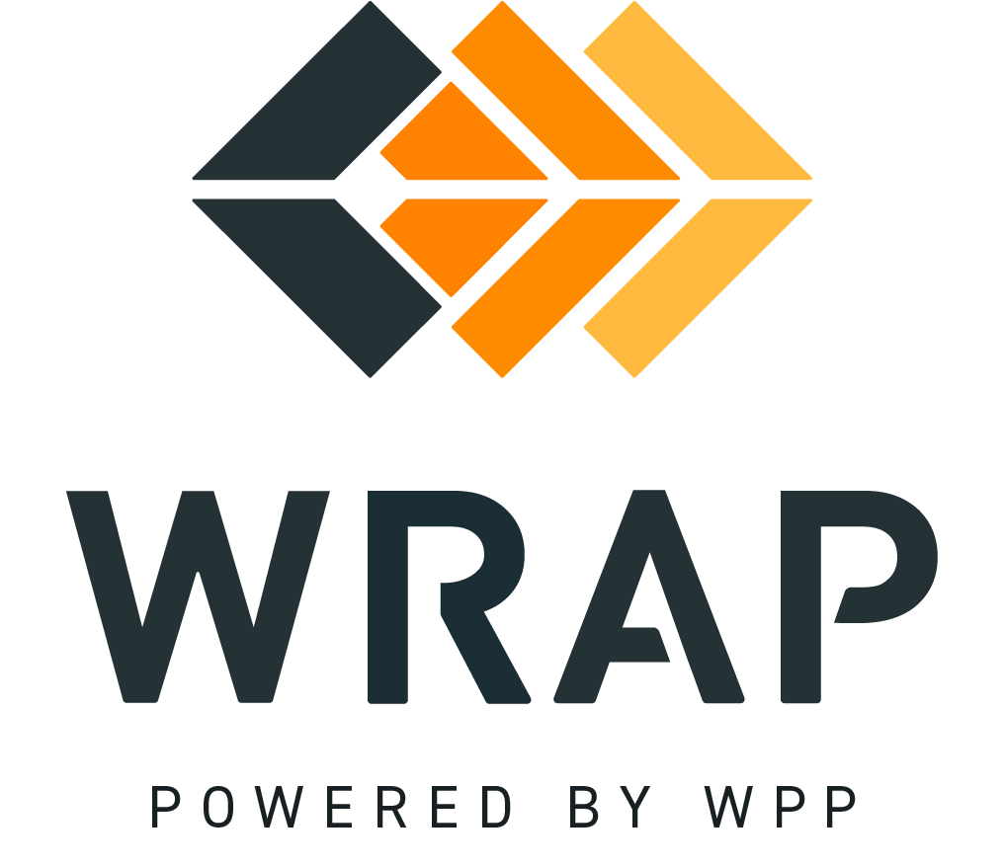

2025-NTFP-04 (2025-CRF-008)
Comments accepted between 2025-12-18 and 2026-01-15

01. Please supply any comment related to the proposed changes in the Tariff.

02. Please supply any comment related to the proposed changes in BPM 106.

03. Please supply any comment related to the proposed changes in BPM 107.

04. Please supply any comment related to the proposed changes in BPM 108.

General Comment

