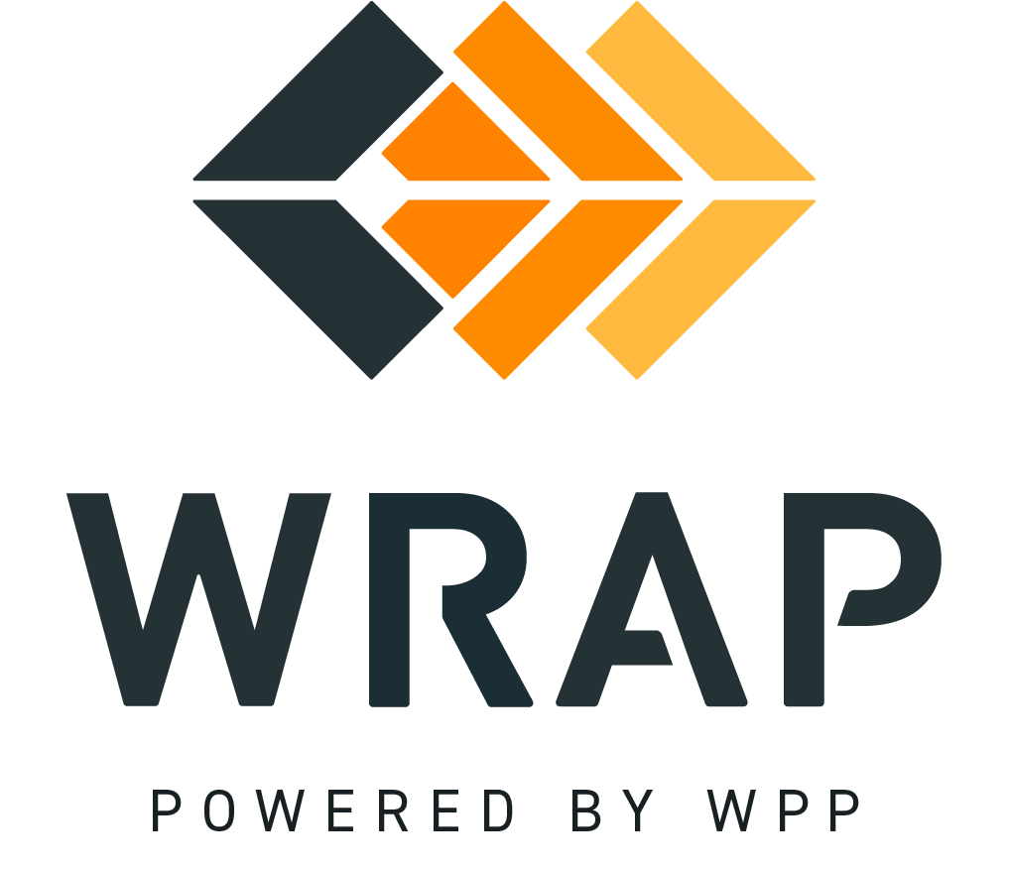

2026 Draft PRC Workplan
Comments accepted between 2026-03-13 and 2026-04-15

01. Please supply any comments on the draft Task Force Schedule found in Figure 5 (Schedule III)

02. Please supply any comments on Concepts that would provide valuable clarification ahead of the March 31st, 2027, Forward Showing Deadline for the first Binding Season of Winter 2027-2028

03. Please supply any comments on the Executive Summary

04. Please supply any comments on Section 1. Background

05. Please supply any comments on Section 2. PRC Prioritization Exercise

06. Please supply any comments on Section 3. Detailed Level of Effort Review

07. Please supply any comments on Section 4. Proposed Schedule and Plan of Action

08. Please supply any comments on Appendix A - Change Request Form Compilation

09. Please supply any comments on Appendix B - PRC Minutes Dec. 18th, 2024

10. Please supply any comments on Appendix C - PRC Minutes Jan. 28th, 2026

11. Please supply any comments on Appendix D - PRC Minutes Feb. 11th, 2026

General Comment

