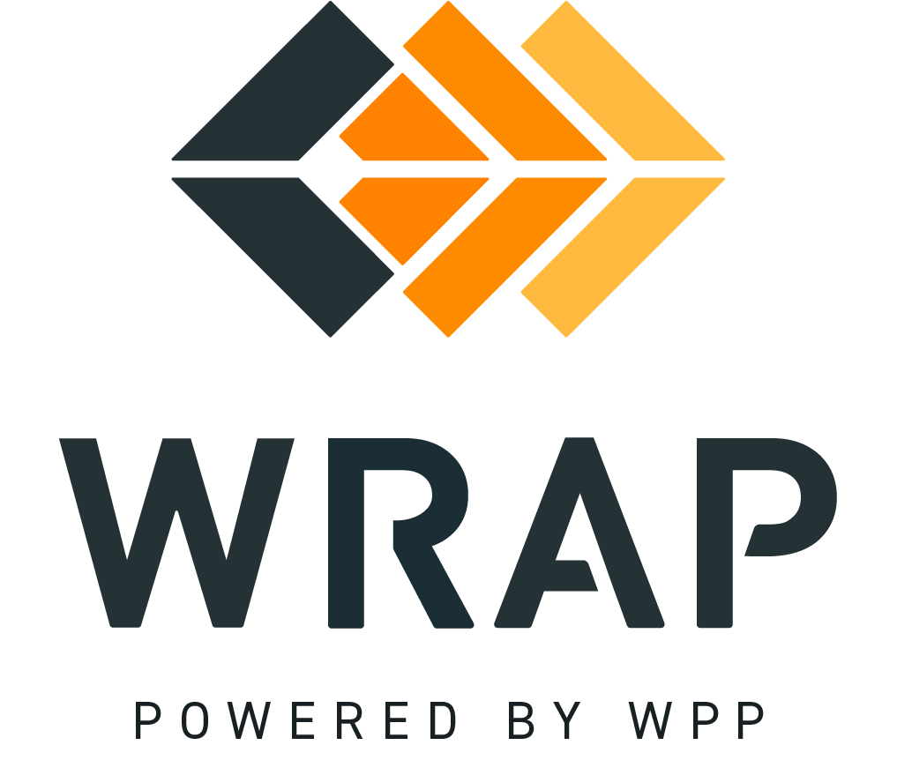

2026-NTFP-05
Comments accepted between 2026-06-10 and 2026-07-01

01. Please supply any comments related to the proposed changes in BPM 107 - Section 3.2 Calculating Deficiency Charge

02. Please supply any comments related to the proposed changes in BPM 107 - Section 7.1 Binding and No-Binding Seasons in Forward Showing Year

03. Please supply any comments related to the proposed changes in BPM 108 - Section 2.1 FS Deadline Extension Due to Forward Showing Software System Failures

04. Please supply any comments related to the proposed changes in the WRAP Tariff - Sections 14.6-14.8 (pg. 43)

05. Please supply any comments related to the proposed changes in the WRAP Tariff - Section 15A.3 (pg. 46)

06. Please supply any comments related to the proposed changes in the WRAP Tariff - Section 17.4 (pg. 64)

General Comment

