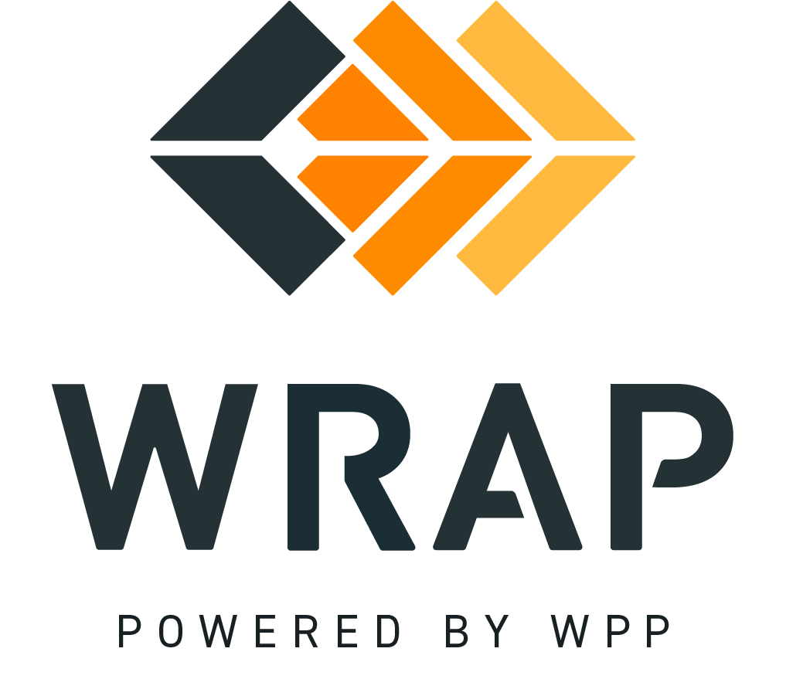

2026-EP-03 (Deficiency Charge Deferral)
Comments accepted between 2026-09-10 and 2026-09-24

Please supply any comments related to the proposed changes in BPM 109 - Forward Showing Transition

Please supply any comments related to the proposed changes in BPM 210 - Binding and Non-Binding Participation in Operations Program

Please supply any comments related to the proposed changes in the WRAP Tariff

General Comment

