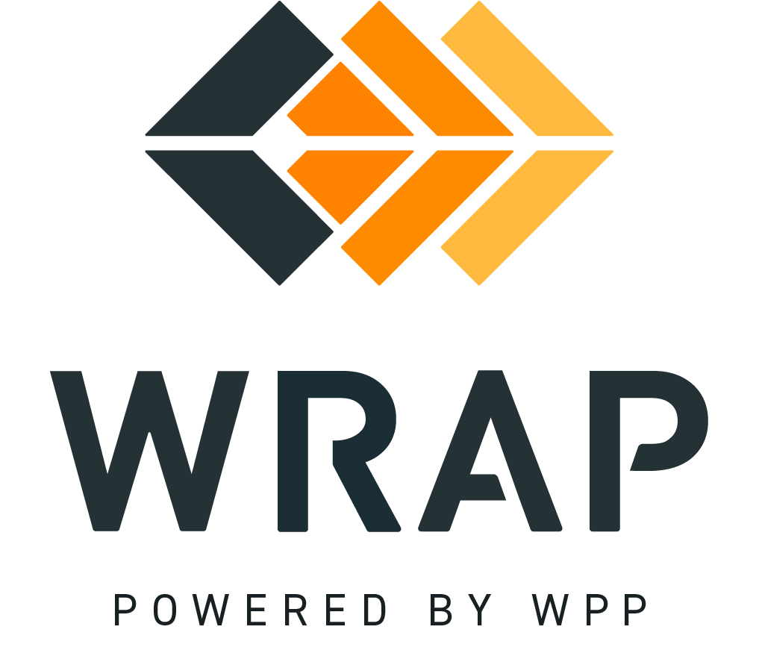

2026-EP-04 (New Rockies Subregion)
Comments accepted between 2026-09-10 and 2026-09-24

Please supply any comments related to the proposed changes in BPM 102 - Forward Showing Reliability Metrics

Please supply any comments related to the proposed changes in BPM 103 - Forward Showing Capacity Requirements

Please supply any comments related to the proposed changes in BPM 105 - Qualifying Resources

Please supply any comments related to the proposed changes in BPM 108 - Forward Showing Submittal Process

Please supply any comments related to the proposed changes in BPM 206 - Settlement Pricing

Please supply any comments related to the proposed changes in the WRAP Tariff

General Comment

