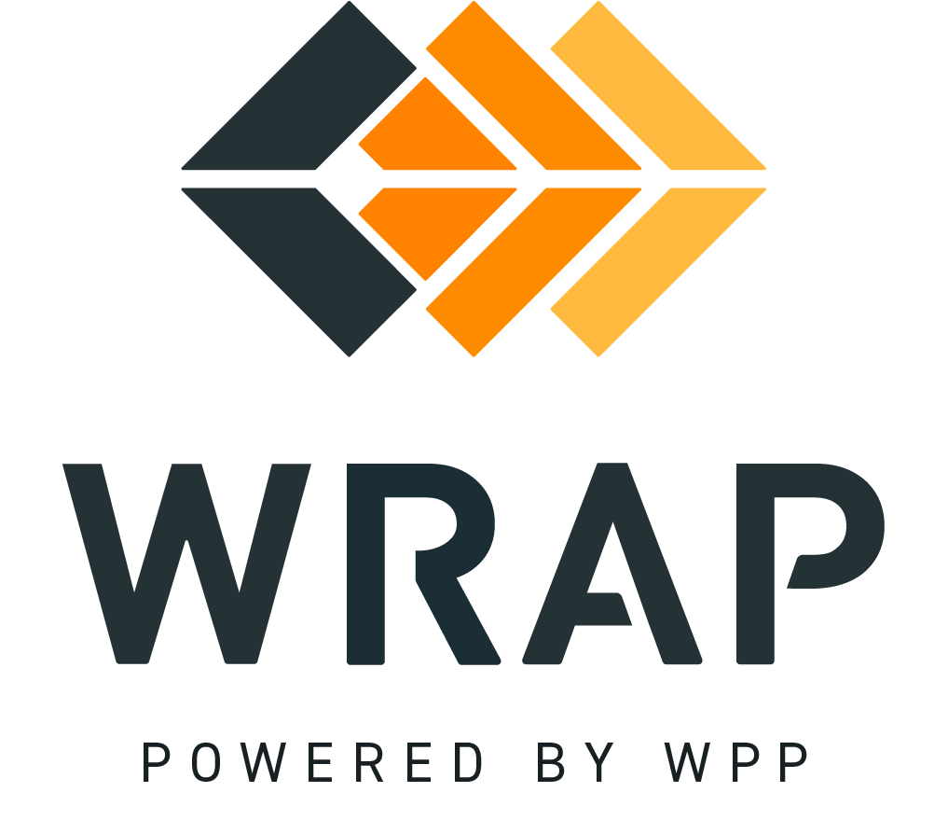

2026-EP-05 (CCH By Subregion)
Comments accepted between 2026-09-10 and 2026-09-24

Please supply any comments related to the proposed changes in BPM 104 - Capacity Critical Hours

Please supply any comments related to the proposed changes in BPM 108 - Forward Showing Submittal Process

Please supply any comments related to the proposed changes in the WRAP Tariff

General Comment

