Operations Training Subcommittee
Nov 1st, 2023
Agenda

- Introduction and Arrangements Rob Witham, CHPUD
Safety roles covered, intro covered by Rob
Reminder: active OTS Rep list posted on main website as an excel file. Don’t trust the default .org member listing.
Adam SOlomon new trainer for Xcel, hello
Jose and Lloyd with APS new, hello
Justin with IID, hello
- Review action items from last meeting Harlan Tallman, WPP
Action Item: Jessica to post Access Policy to Corporate Website before end of day

Action Item: Staff to ask adjacent Staff re: WRAP Tag Templates [done]

Action Item: Jess to make EEA Language Update a Global Asset [done]

Action Item: Jessica to send out (including SRSG) on Lesson Plan template from Seattle. Thanks Denise.

Action Item: Jess to upload/update past quarter’s metrics to OTS portal.

Action Item: make metric Per CEH/cert user

Action Item: Jess to reach out to contact on PCGC for what it would take to get a partial-hour CEH

- Source Subscription Update Keith Schreiner, WPP
Subscription money is doing its job, more coming in with interest.
Subscribers do not have access to the toolkit creation suite.
Staff would like to increase the functionality of the toolkit before it is considered for subscriber access.
Users still want a Sim experience; a WIP.
- Penalties for user agreement infractions. Keith Schreiner, WPP
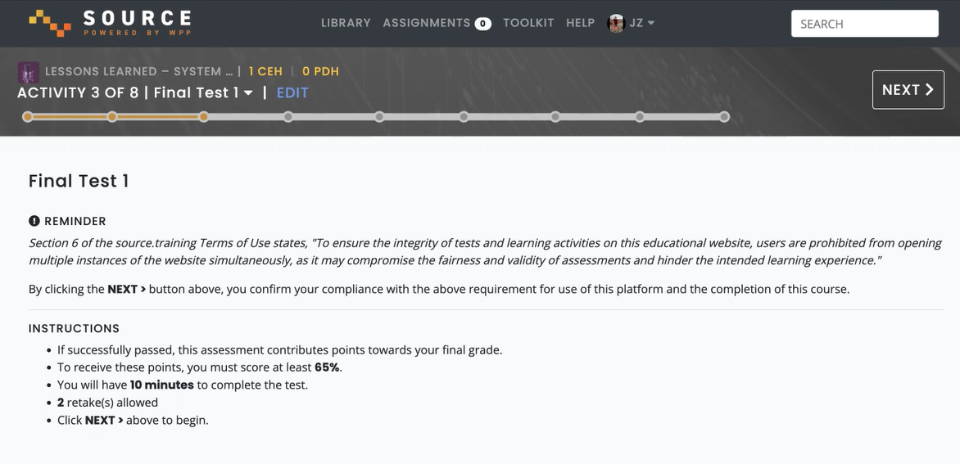
This has been included to all Final Tests to help push forward honest test-taking.
What is a viable penalty for this level of dishonest course-taking? Current vote is to revoke the cheated CEHs. Some trainers have internal policies to follow-up with any Operator taking 3+ courses a day. Reminder if a Trainer wants to suspend one of their Op users, WPP Staff or the Trainer can do that on the site via account permissions and ‘archive’ them. Trainers could email blast their shops to notify them a ‘bad operator’ cheated and lost the 48 CEH as a result. Can include the possible loss of CEHs to the above warning card, and include the card at the top of the course as well.

Action Item: Staff to add the “ULA Summary” to the top of a course, and include the threat of CEH-revocation to the Summary card.
- SRSG, WRAP, Corp Updates Jessica Zamonis, Ryan Roy WPP
SRSG DSTAC going real well. Zones and Cutplanes re-evaluated, moving some existing BAs around prior to SRSG go-live.
WRAP summary course on Source.Training, as WRAP moves forward there will be space on Source for training videos.
Corp Updates: Staff doing Town Hall visits, opening a forum for blunt discussion on the road with members. Learning that all groups under the WPP umbrella don’t interact much with each other. WPP Staff sees a use for ‘cross pollination.’ Just go through the proper procedures for guests at closed meetings (RSGC, OC, etc)
Nov 16th doing a Town Hall in Phoenix, Staff’s last hall meeting.
Also working on hiring Greg Park replacement.
Action Item: Staff to develop a draft “BA Member Internal ‘Town Hall’ “ agenda to help member Reps to discuss internally their roles and responsibilities regarding WPP
- RSG Program Update & Course Impacts Jessica Zamonis, WPP
Staff working on an in-person Classroom Training, to be recorded for footage, sometime prior to the RC Drills (Prior Feb 12th)
Staff developing a SIM activity to let trainees input resources to calculate their Contingency Reserve Obligation, go through the reserve sharing request making process, Staff will make it a resource once completed if able (as the resource is built on Captivate, so trainers may need to custom-tweak it to make the values relatable.)
Mossyrock Bluecut Fire podcast is not in line with EOP-11 and is out of date regarding EEA Qualifying Events. Would need a crazy huge overhaul. Staff would like to pull it by Next Friday.
Action Item: Staff will pull the course by 11/10 and Staff will trim and edit it into a Bluecut podcast for no CEHs to maintain the knowledge within.
- 24/25 Budget Discussion All
WPP Staff needs new and more staff to keep up with growing training scope. Maintenance on the site and content is not giving time for production of content.
Need a junior trainer and junior trainer.
OTS members seem on board for the hiring process.
Need to vote to take this to the OC.
Action Item: WPP Staff to bring to OC the proposal for including new Training Staff into the ’24-’25 budget. Motion by Rob Witham, seconded by Kevin Madden.
- SOCCED / Provider Update All
    - Fee change
SOCCED will increase their fees by start of year
Process of getting half-hour CEHs, at the CMEWG level it’s very popular, to be discussed at the PGCG today. Hopefully progress continues. Jess will distribute any news/changes on that front as it becomes available.
25% different questions / order in Process Manual is apparently removed from the current documentation and future documentation. ‘fail’ ‘test’ ‘25%’ are all gone.
Check the ‘testing’ section for changes.
- Platform Check-In David Pennington, WPP
Metrics page will have up-to-date Metrics to be available on Source; popular courses, CEHs by month, leaderboards, etc.
On the Roster page you can invite, manage and download reports.
Assignments page to track batch assignments and completion rates, and individual user completion within the batch. Red courses are overdue courses.
What would you like to do with completed assignments? New tab sounds like the plan.
Pool-wide leaderboard? Popular courses to toggle into per-company and/or pool-wide? CEH/cert?
Action Item: David to distribute an intro video on Dec 1st, when the new features on Source go live.
- Metrics Discussion Jessica Zamonis, WPP
Courses Delivered, more and more companies coming on board. If your company isn’t on here, you’ve taken no courses this Q3. CEHs Delivered is just to qualified users.
Top 5 courses: emergency preparedness, reserve sharing essentials and reserve sharing QE, 2023 RSG EEA update and space weather. Mostly due to SRSG integration.
RC Access, RC West at almost 90% and SPP RC at almost 40%. Of note both were at 0% last quarter.
For SRSG specifically, TEP is leading with 350+ CEHs delivered, Arington and Calpine at zero (though they are taking courses without CEH awarded)
CISO is on board now, so is Onward and Redding.
RSG has a goal for reps and alts to take at least one RSG course every three years. Almost at 75%, some are not active members.
- NERC test Prep Endeavor Keith Schreiner, WPP
Keith asks for more things.
NERC Prep Course to help facilitate users become ready for the NERC test. Keith to reach out to near-retirement folks as information sources to develop content long-term as contractors.
“Office Hours” for retired professionals

Action Item: Keith to do leg-work for reaching out to contacts for phase 1 of NERC Test Prep
- New course updates and requests Jessica Zamonis, WPP
Next workload batch is RSG related, to make content accurate after changes.
EIM interview footage filmed in August, that might be next.
Volunteers for WEIS come spring
Non-CEH course pitch: SAT-style train the trainer course, people like the idea.
WPP staff will need to coordinate schedules to get involved with RC Drills come Jan 2024.

- Action Item Review Harlan Tallman, WPP
Action Item: Staff to add the “ULA Summary” to the top of a course, and include the threat of CEH-revocation to the Summary card.
Action Item: Staff to develop a draft “BA Member Internal ‘Town Hall’ “ agenda to help member Reps to discuss internally their roles and responsibilities regarding WPP
Action Item: Staff will pull the course by 11/10 and Staff will trim and edit it into a Bluecut podcast for no CEHs to maintain the knowledge within, with email notifications.
Action Item: WPP Staff to bring to OC the proposal for including new Training Staff into the ’24-’25 budget. Motion by Rob Witham, seconded by Kevin Madden.
Action Item: David to distribute an intro video on Dec 1st, when the new features on Source go live.
Action Item: Keith to do leg-work for reaching out to contacts for phase 1 of NERC Test Prep
Action Item: WPP Staff to add Metrics and Notes to WPP Site’s post-meeting card item.
- Next Meeting Jessica Zamonis, WPP

